**Neural Net Testing**

For our neural network testing, it was first planned to run percentage split tests on 10%, 20%, 30% and 40% holdouts. Not finding a conclusive “best” holdout percentage from these tests, we continued and tested on 50% through 90% holdout at 10% intervals. Some of these tests are shown here to provide the readier with a good understanding of the data. The rest are shown in Appendix A.

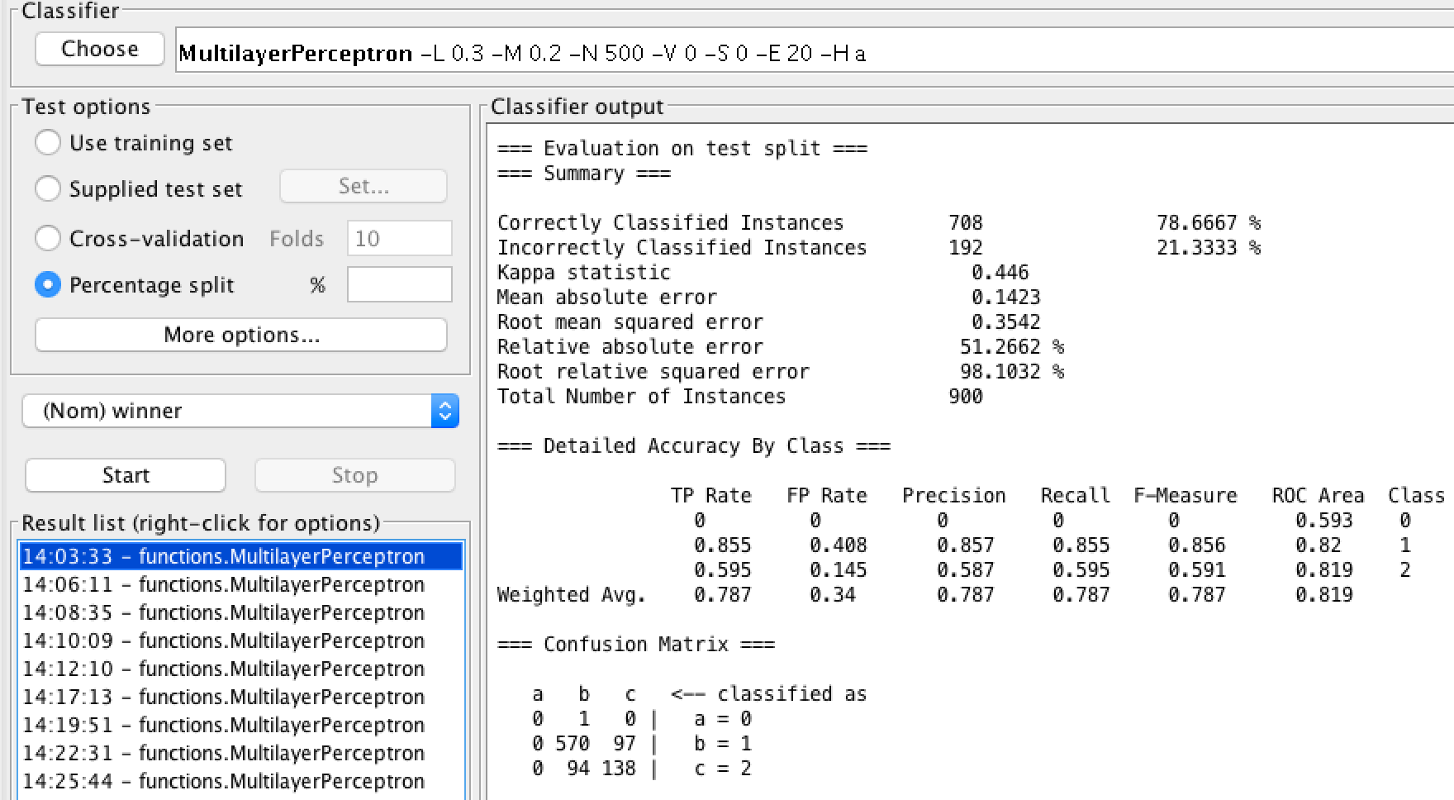

10% Holdout:

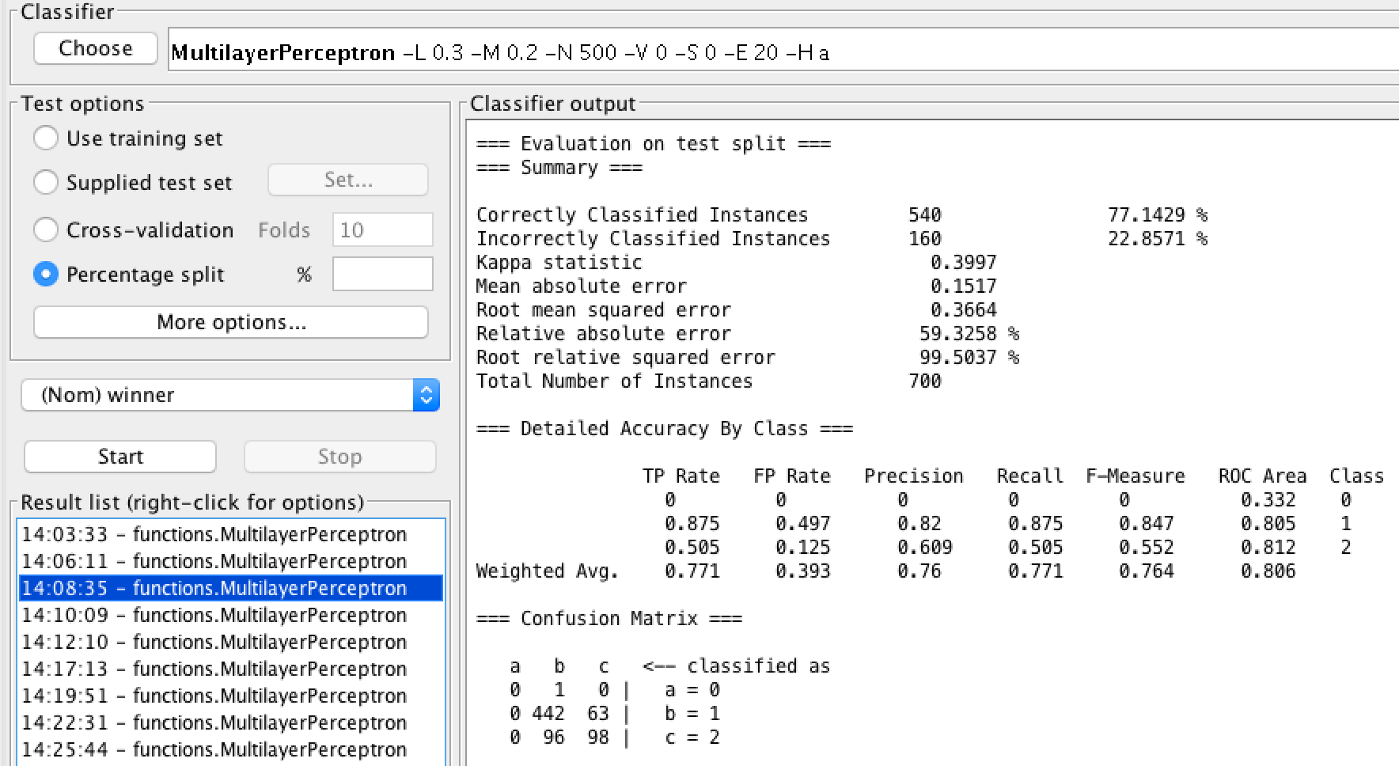

30% Holdout:

50% Holdout: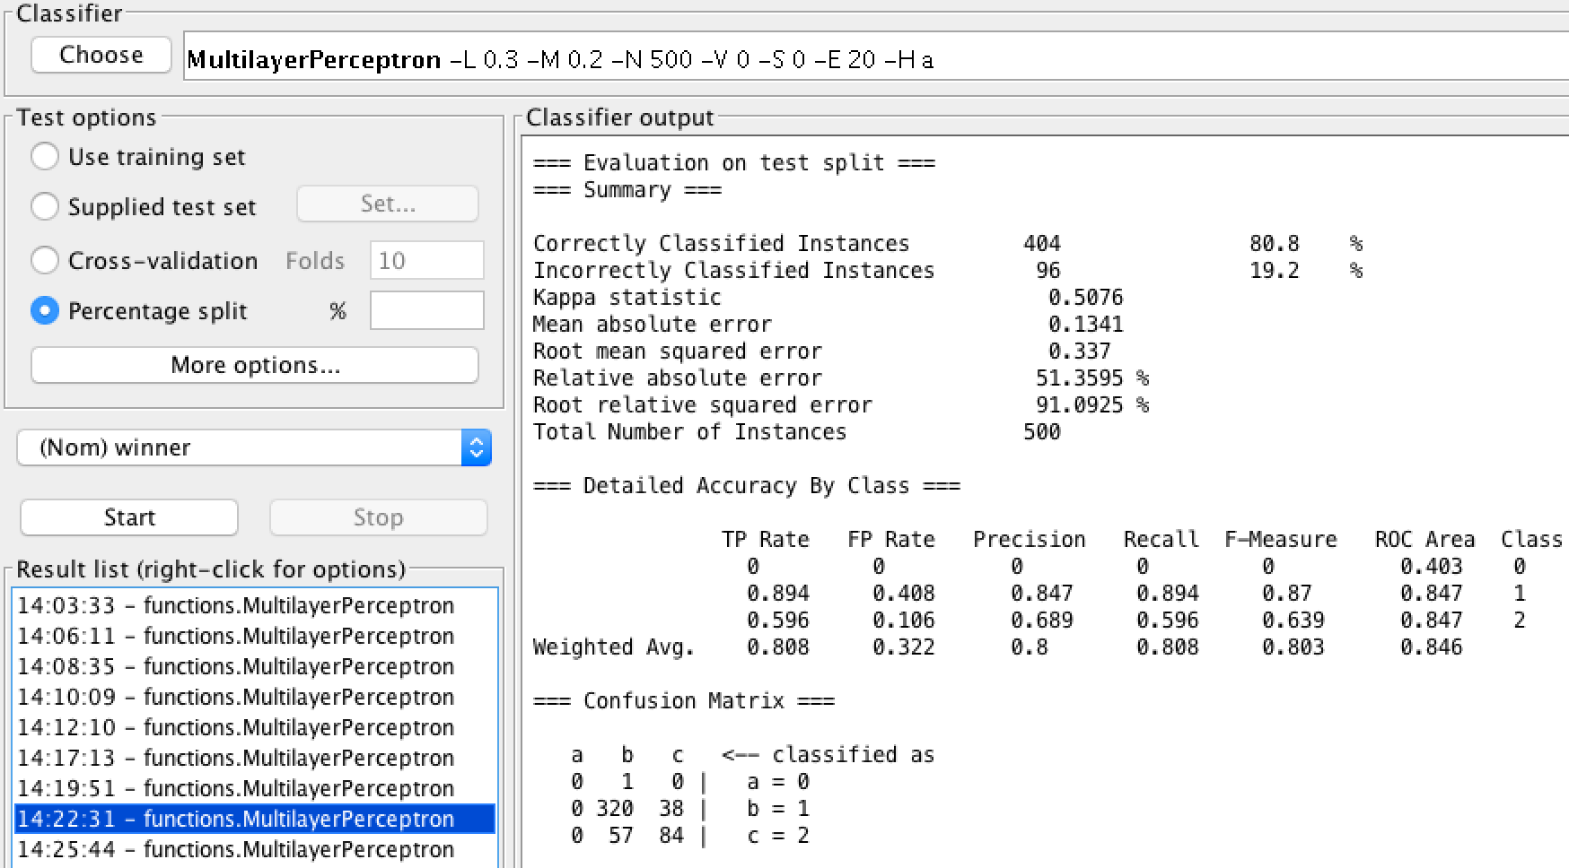

70% Holdout: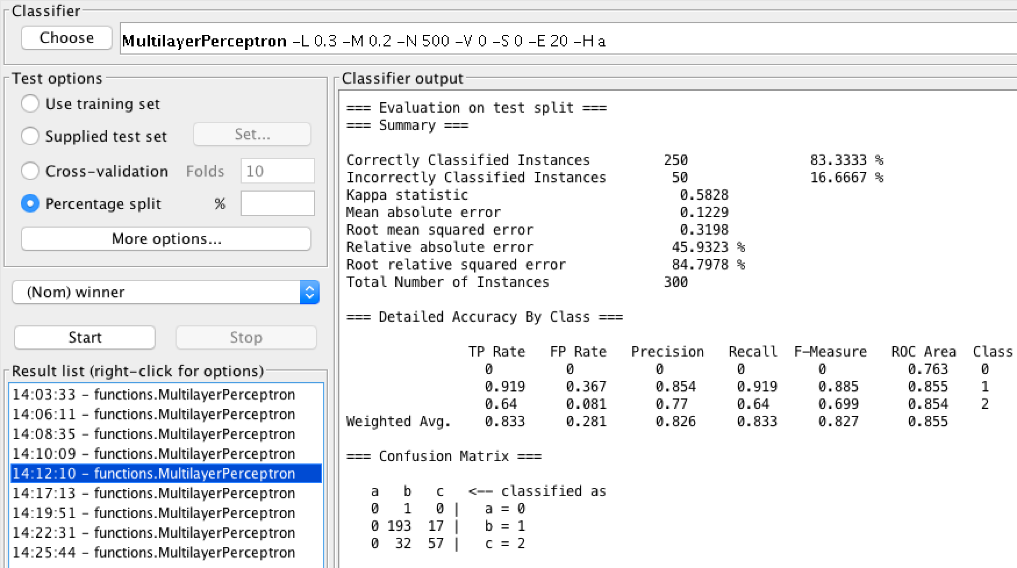

90% Holdout: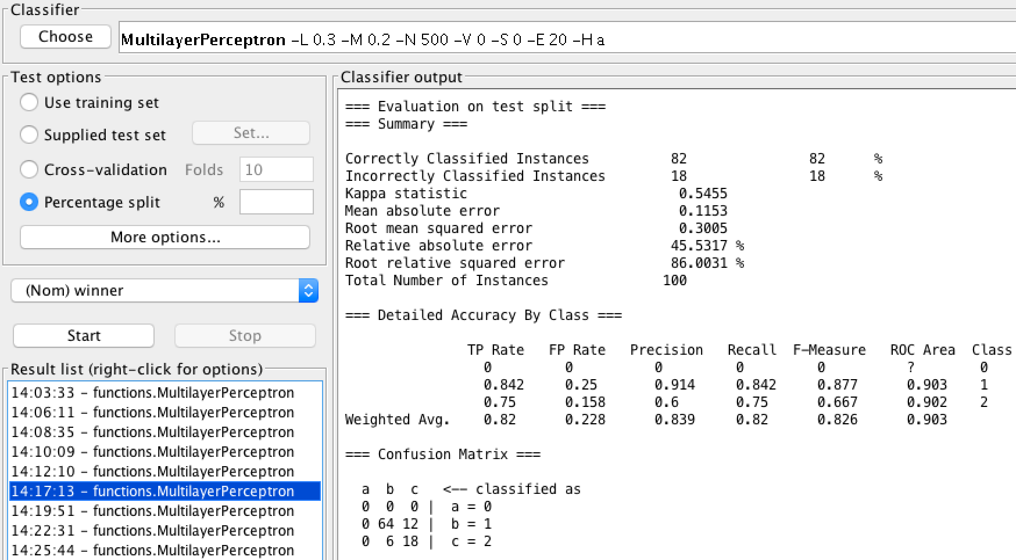

The highest percentage of correctly classified instances was 83.33% correct, which occurred at 70% holdout percent. This was a surprise, as it needed only 300 datapoint of the provided 1000 to train a very good neural network. This does make some sense though, as the 300 datapoint may provide less overfitting that could cause problems when attempting to correctly tune a neural network.

We then tested a neural network using KFolding, with K-folds of 3, 5, 10 and 25.

K = 3: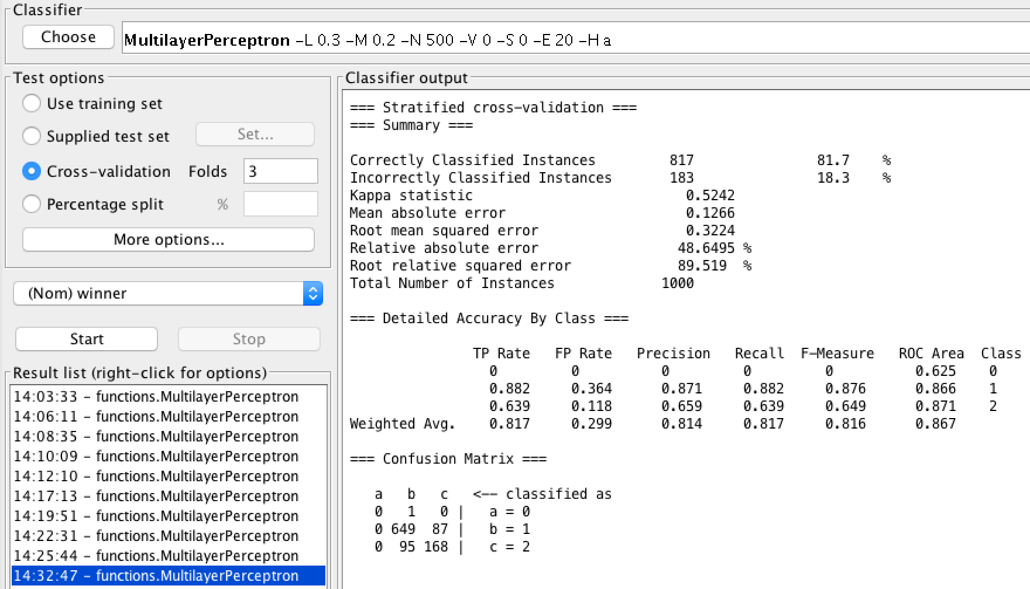

K = 5: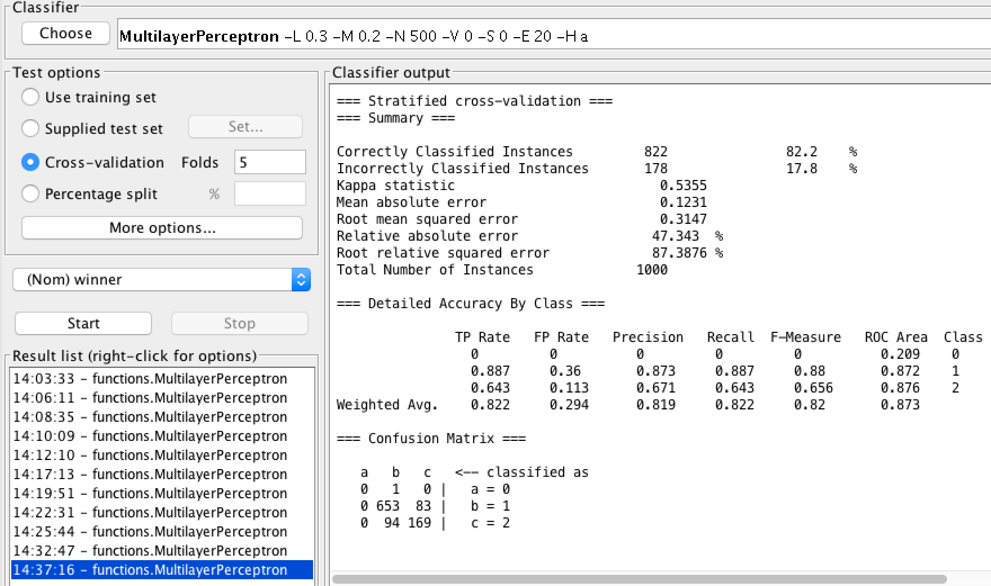

K = 10: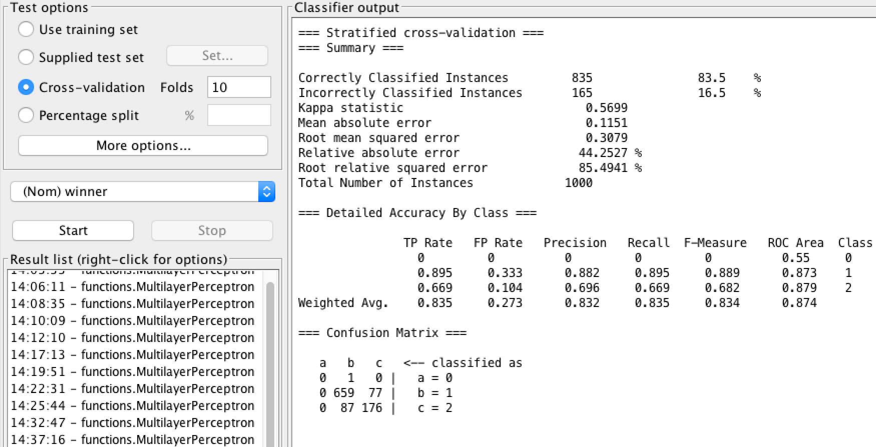

K = 25:

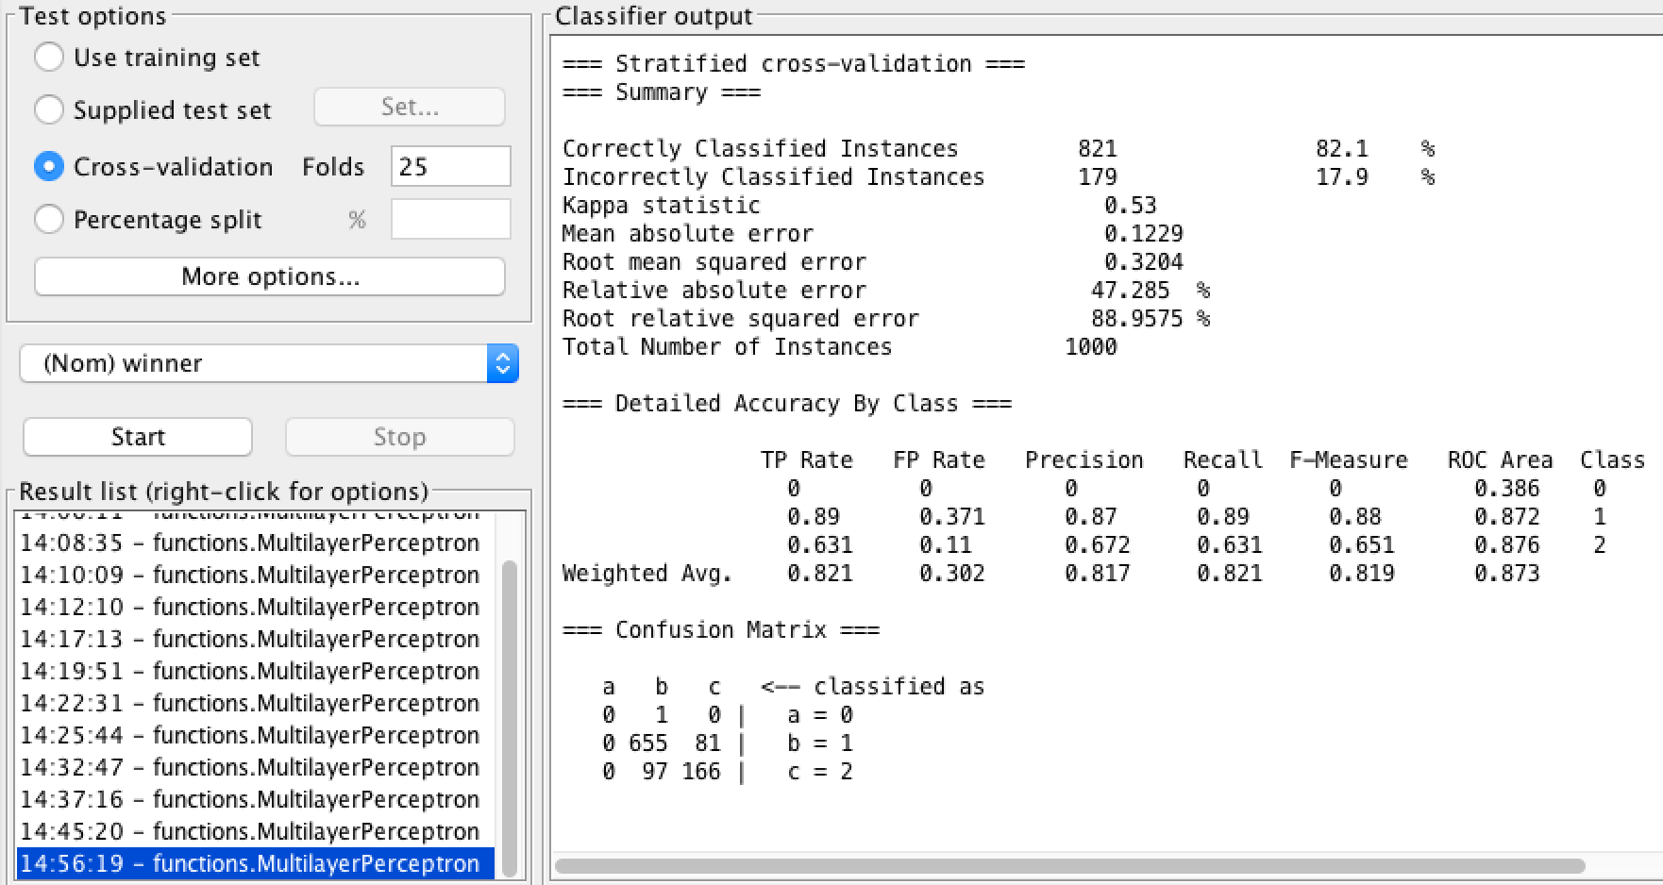

The best number of folds we found was k = 10, which trained the neural network to correctly clarify instances in 83.5% of cases.

K-folding was much more consistent in percentage classified correctly than holdout percentages when looking across a wide range of different holdout percents or k-folds. K-folding was on average a better method, too. K-folding and holdout percentages both were able to produce almost exactly the same level of correctly classified instances at peak, however. Because of this, we are unable to draw any strong conclusions as to which is a better method for training a neural network.

**Appendix A:**

20% Holdout: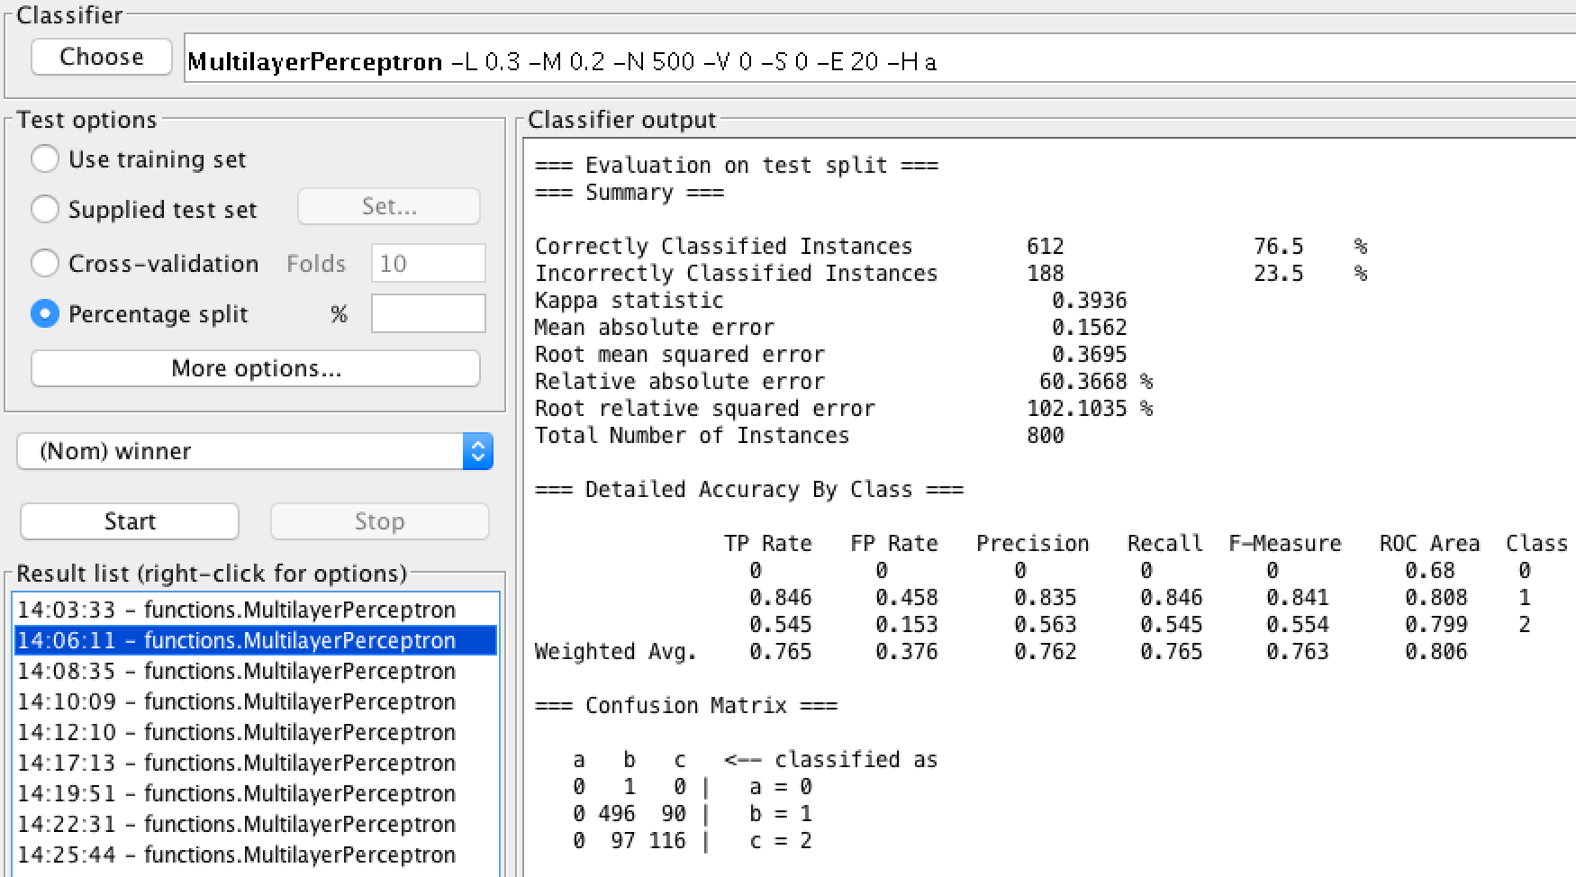

40% Holdout: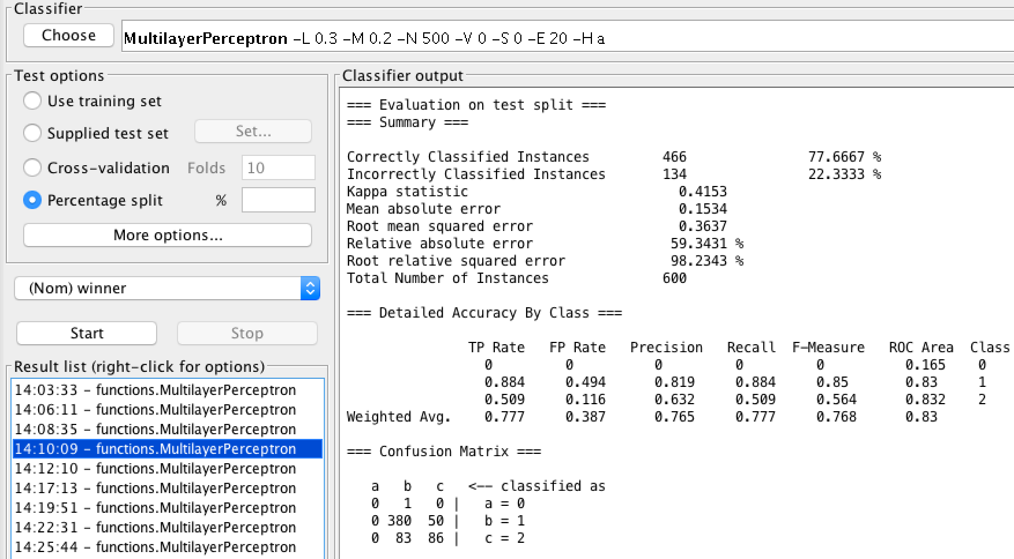

60% Holdout: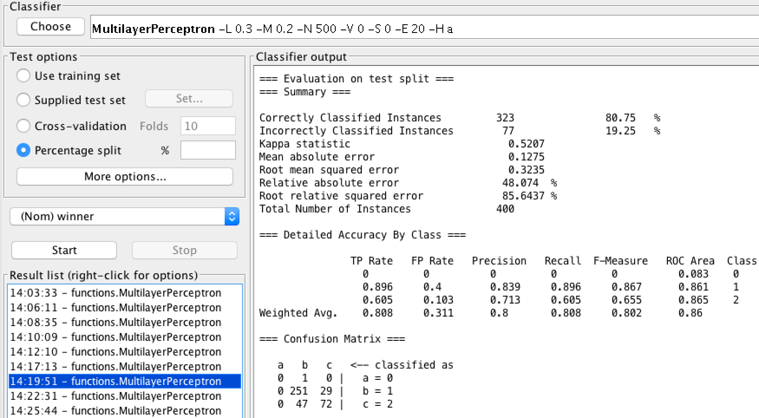

80% Holdout: